|  |  |
| --- | --- |
| http://s7d9.scene7.com/is/image/BedBathandBeyond/30396141615270p?$478$  Homedics 900 Dual Digital Scale | Prestige Worldwide  Ashlyn Aiello  Jerome Andaya  Paroma Mallick  Ali Nawaz  Zack Woo |

**Abstract**

The HoMedics 900 Dual Digital Scale is a traditional glass scale that displays weight using a dial as well as LED display. The purpose of reverse engineering the scale was to better understand both the mechanics of a seemingly simple product and the engineering design that enables it to function properly. The reverse engineering process provided insight into the various components necessary to make a scale, the flow of energy that enables those parts to work together, and the basis upon which the particular design was chosen for manufacturing efficiency and practical use.

**Summary**

        Disassembling the HoMedics 900 Dual Digital Scale revealed several components necessary for a weight measuring device. Strain gauges first converted weight, or force, into an electric signal. LEDs and an LCD worked in tandem to display digital numbers, and gears powered by solenoid magnetic fields turned an analog dial to the correct position.  In addition, a microprocessor and circuit board, as well as glass plate and plastic housing, were necessary to interpret electrical data and contain the device. Alternate designs include fewer support feet and use of springs instead of strain gauges, however the HoMedics design seemed adequate in stability, functionality, and cost.

**Introduction & Overview**

The HoMedics 900 Dual Digital Scale has both analog and digital features. It is 12.4” x 15.35” and has a 1.5” backlit LED display. There is also a button to change units between pounds and kilograms. The “auto on” feature enables the scale to turn on when pressure is applied to the glass plate, and strain gauges in each of the scale’s four feet convert weight to an electrical signal that is sent to a microprocessor within the scale body. The microprocessor interprets the signal and performs specific calculations depending on the chosen units, then relays the signal to run a series of solenoid-powered gears that turn the analog dial. The signal also contains information that enables the LED screen to display information to the user.

**Problem Statement**

The main function of the scale is to measure the weight of an object and to display that information in a way that is useful for the user. For example, a bathroom scale is likely more useful if it measures in pounds rather than in newtons. The scale needs a way of accurately detecting this weight, to the tenth or hundredth of a unit, and should be able to alter its measurement depending upon the units specified by the user. In addition, this particular scale should have the ability to rotate a dial to a degree proportional to the weight measured and also display a numerical value on the LED screen. Finally, the entire scale must be light, portable, and durable to put up with people constantly stepping on it, and it must also be contained in an aesthetically pleasing device that will sell on the goods market.

**Design Alternatives**

The scale measures weight through its contact points with the ground, and although one contact point might be the most simple method for calculating weight, such a scale would be unstable and inconvenient to use. Instead, the scale uses four feet each equipped with strain gauges that measure the weight applied to the scale. The strain gauge is one of the most important tools for electrical measurement. As more force is applied to the strain gauge, the resistance across it changes. For example, when the strain gauge is stretched, the resistance across it decreases, causing an increase in current.

Thus the strain gauge converts force, tension, and pressure into an electrical signal according to Ohm’s Law (see appendix). As the slim piece of metal is stretched, it becomes thinner and longer, changing resistance and inducing a current. This current is then sent to the microprocessor chip that is located behind the LED which displays the weight on the LCD screen and simultaneously moves the analog dial.

There are two ways the scale displays weight: an analog dial and a backlit LED display. The analog dial is powered by a set of tiny gears in a circular black box at the back of the scale. Two solenoids are located on either side of the main gear on the shaft that is attached to the dial. The main gear is made of plastic with small metal attachments on it. There are also three other gears that enable the dial to turn smoothly.

When the microprocessor receives a pressure reading, it allocates voltage from a capacitor on the circuit board to run through the solenoid wires. The current flows through the solenoids in opposite directions, one clockwise and the other counterclockwise. These opposite currents create a magnetic field causing torque on the gear which turns the dial to the correct position. A cutout with weights oriented radially like numbers on a clock enables the LED backlight to illuminate the numbers and allows users to read their weight measurement even in the absence of light.

The LED display shows weight measured by the scale as a numerical reading. Four white LEDs light up a glass light diffuser which distributes the light evenly across a glass plate. This provides background light that shines through a liquid crystal display (LCD). The pixels of an LCD screen consist of two polarized filters, one horizontal and one vertical, separated by a liquid crystal layer. As the light passes through the first polarized filter, only those waves vibrating in a certain direction, for example horizontal light waves, pass through. However, liquid crystals rotate the plane of light, so those horizontal waves become vertical and are able to pass through the second polarized filter which is oriented at 90 degrees from the first. This pixel is on. When liquid crystals are supplied with an electric current, they do not rotate light, and the horizontal waves that passed through the first filter will be blocked by the second filter, turning that pixel off. The microprocessor coordinates individual pixels in LCDs to display numbers or images. Though not the most cost-effective method of displaying a weight reading, the LCD displays large, easy to read numbers that make it a convenient alternative to analog display.

**Evaluation of Design Alternatives & Basis for Selection**

Other types of scales include spring scales and electronic scales. Spring scales consist of a spring that is fixed at one end and attached to the mass being weighed at the other. They depend on Hooke’s Law which states that weight is proportional to the distance a spring is stretched (see appendix). A spring scale would not be as useful as the HoMedics scale for weighing a person because it would be anchored in the ceiling which would have to withstand the weight of a human. Also a spring with sufficient stiffness to hold up to 300 pounds would be expensive to manufacture, and the entire device would be large and inconvenient to use.

        Electronic scales include a microprocessor and are faster, more compact, and can measure heavier loads than spring scales. The HoMedics scale’s dual system creates a redundant safety system that allows it to function even in the electronic parts malfunction.

        The HoMedics scale is sufficiently light, compact, accurate, and ensures long-time use because of its dual digital-analog function. Though some consumers may see the dual display as an unnecessary component, the large numbers do help the visually impaired to clearly read their weight.

**Appendix**

**Bill of Materials:** Please see “Bill of Materials.pdf” or “Bill of Materials.xlsx” files for a better view.

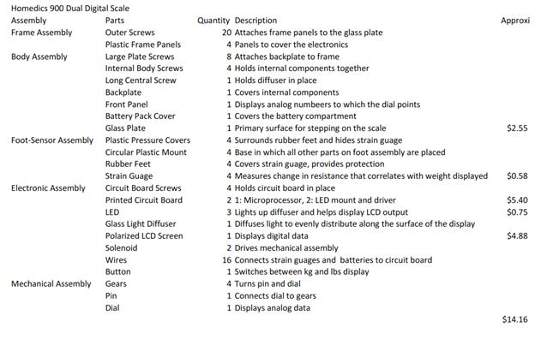

**Hooke’s Law:** F = kx, F is force, k is spring constant, x is distance stretched. Hooke’s Law states that force is equal to a spring constant times the distance the spring is stretched. The spring constant depends on the stiffness of the spring being used. Large spring constant constitutes stiffer spring, and small spring constant indicates a flexible spring.

**Ohm’s Law:** V = IR, V is voltage, I is current, R is resistance. Ohm’s Law states that voltage is equal to current times resistance. Because a constant voltage flows through a circuit, a change to the resistance will affect the current. Increased resistance decreases the current, and decreased resistance increases the current.